*Environmental drivers of taxonomic and functional diversity of riparian plant communities in a modified landscape.*

James R. Lawson*1, Kirstie A. Fryirs2, Rachael V. Gallagher1, Cassandra S. James3, and Michelle R. Leishman1

1. Department of Biological Sciences, Macquarie University, New South Wales, Australia
2. Department of Environmental Sciences, Macquarie University, New South Wales, Australia
3. Centre for Tropical Biodiversity and Climate Change and Centre for Tropical Water and Aquatic Ecosystem Research, James Cook University, Townsville, Australia

* [james.lawson@mq.edu.au](mailto:james.lawson@mq.edu.au), fax: +61 2 9850 8245, phone: +61 2 9850 8160

Running title: “Drivers of riparian plant diversity in modified landscapes”

Keywords: riparian vegetation, functional trait, functional diversity, environmental heterogeneity, flow modification, land use

SUMMARY

1. Human populations have a profound impact on the biodiversity of riparian plant communities, and understanding the nature and mechanisms of these impacts is central to river conservation and rehabilitation. Reduction of the inherent environmental heterogeneity in riverscapes by flow modification and land-use intensification is thought to cause degradation of riparian communities.
2. We sampled vegetation and assembled environmental data for 20 river reaches in south-east Queensland, Australia. Plant functional trait data collated from online databases and the ecological literature were used to characterise diversity in terms of ecological strategy and functional effects. Our aim was to tease apart the importance of environmental factors associated with taxonomic and functional trait diversity in riparian plant communities. We specifically tested the hypotheses that environmental heterogeneity is the dominant control on taxonomic and functional trait diversity, and that flow modification and land use intensification is associated with reduced plant diversity.
3. Contrary to our expectations, hydrological metrics of environmental heterogeneity had limited power to explain patterns of species richness. Rivers which experienced seasonal, but temporally consistent flow regimes supported the most species rich communities, and modification of flow regime towards temporal consistency was also associated with greater species richness. Functional diversity metrics showed unimodal relationships with some metrics of hydrological heterogeneity, but were only weakly predicted by flow modification and showed no relationship with catchment land-use intensity.
4. The absence of strong linkages between the extent of flow modification and metrics of functional diversity suggests that use of environmental flows may not be broadly effective as a tool for riparian rehabilitation in modified subtropical landscapes such as south-eastern Queensland.

INTRODUCTION

Riparian ecosystems are highly biodiverse, provide important ecosystem services and are the focus of substantial management effort worldwide (Naiman, Decamps & Pollock 1993; Palmer *et al.* 2009). Rapid development of catchments has changed fundamental processes which create and maintain biodiversity within riparian landscapes (Nilsson & Svedmark 2002), and as such, riparian management often takes place within this context of catchment modification. Wholesale vegetation clearing notwithstanding, regulation of river flow regimes, and catchment land-use change are considered key drivers of ecological change (Nilsson & Berggren 2000; Cooper *et al.* 2013). Maintaining indigenous plant assemblages and their associated ecosystem functions, and controlling invasive species, are central goals in river rehabilitation and riparian conservation (Richardson *et al.* 2007)

Environmental heterogeneity is one of the major factors influencing spatial patterns of species diversity (Costanza, Moody & Peet 2011; Stein, Gerstner & Kreft 2014). According to classical niche-based theories of species co-existence e.g. (Chesson 2000), where each niche is associated with an optimal ecological strategy, structural complexity and steep resource and energy gradients between patches promote diversity by extending niche space and reducing niche overlap. More recently, niches have been characterised in trait-space: niches and their interrelationships are described by patterns of clustering of functional traits (any morphological, physiological or phenological feature measurable at the individual level (Violle *et al.* 2007), the values of which are optimised to a given set of environmental conditions (Adler *et al.* 2013). Thus the distribution of functional traits within a community can be expected to be patterned by the degree of heterogeneity in environmental conditions present. Describing communities in trait space dissolves species distinctions and emphasises ecological strategies: what species do within their community and how they do it. In turn, metrics of diversity derived from functional traits provide a useful complement to taxonomic diversity metrics, as they allow a mechanistic characterisation of biodiversity-ecosystem functioning relationships (Hillebrand & Matthiessen 2009).

Much of the riparian ecology literature identifies hydrology and geomorphology as the dominant abiotic force structuring riparian ecosystems (Poff, Allan & Bain 1997; Bendix & Hupp 2000). The spatial and temporal heterogeneity inherent in fluvial processes is considered largely responsible for the complex biogeomorphology of riparian environments (Naiman *et al.* 2005; Corenblit *et al.* 2007). Sediments are scoured and deposited, some plants are washed away while others are watered; organic matter and woody debris moves through the system and propagules are dispersed; large flood events have been shown to produce substantial 'heterogeneous imprints' on the fluvial landscape (Parsons *et al.* 2005). The spatial distribution of these processes within the fluvial landscape is contingent on the magnitude and frequency of the flow events that drive erosion and deposition processes, and the resultant morphology and sedimentology of fluvial landforms produced (Fryirs & Brierley 2012). This subsequently determines the extent to which different surfaces/landforms are inundated under a range of different flow conditions (Hughes 1997). Temporal variability in flooding patterns adds a further layer of complexity by influencing the success of plant ecological strategies for a given patch. More frequently flooded patches are likely to support graminoids and rheophytes, while succession is likely to proceed further on patches which are less frequently disturbed (Corenblit *et al.* 2009). Soil moisture conditions are also strongly driven by hydrology in riparian environments, with further implications for plant community assembly (Nilsson & Svedmark 2002).

Intermediate disturbance-type unimodal relationships between fluvial disturbance and species richness are commonly described, e.g. Bendix (1997), Pollock et al. (1998), Bendix and Hupp (2000), Lite et al. (2005), Corenblit et al. (2007). Unimodal relationships between environmental heterogeneity and diversity are also hypothesised to occur as a result of ‘microfragmentation’ at high levels of heterogeneity (Tamme *et al.* 2010). Previous work on riparian plant communities has shown strong positive links between functional trait diversity and flow heterogeneity (Lawson *et al.* 2015): relationships between functional dispersion and metrics of flow variability were mostly monotonic, with the exception of interannual variability in summertime flows, which showed a unimodal relationship.

Over half the world’s large river systems and countless smaller watercourses are affected by dams, weirs and diversions (Nilsson & Berggren 2000; Nilsson *et al.* 2005). While the effects of individual dams tend to be idiosyncratic (Mackay, Arthington & James 2014), flow regulation typically homogenises hydrographs by removing small-moderate flows, reducing flood peaks, altering seasonality and increasing predictability of flows (Graf 2006; Poff *et al.* 2007; Singer 2007). Depending on the magnitude and form of change to the flow regime, flow modification may result in reduced niche complexity in downstream riparian zones (Lloyd *et al.* 2004). In a recent comprehensive review of ecological responses to flow modification, Poff & Zimmerman (2010) found that 152 out of 165 studies reported decreased values for recorded ecological metrics. Invasion by exotic plants in response to flood reduction often results in extensive shifts in riparian plant assemblages and reduction of both taxonomic and functional diversity (Stokes 2008; Merritt & Poff 2010; Catford *et al.* 2011). Terrestrialisation of riparian plant communities has also been described as a response to flood reduction (Poff & Zimmerman 2010).

Human land use also has a profound effect on diversity and functioning in natural ecosystems. Land transformation for agricultural and silvicultural production, urbanisation and resulting habitat fragmentation have resulted in extensive losses of both alpha and beta diversity (Vitousek *et al.* 1997; Gerstner *et al.* 2014). A recent multi-biome meta-analysis found that land-use intensification was associated with diminished functional redundancy and ability to respond to disturbance (Laliberté *et al.* 2010).

Environmental homogenisation of riparian landscapes by this combination of flow modification and land-use change therefore has profound implications for riparian biodiversity. The environmental flows concept posits that given a solid understanding of the hydroecology of a given riparian assemblage, restoration of riparian ecosystems on regulated rivers can be facilitated by releasing engineered flows which support indigenous plant assemblages (Poff *et al.* 2010). The success of such endeavours in modified landscapes, however, is likely to be contingent on the relative contribution of flow modification and other pressures on riparian ecosystems.

To this end, we used a functional trait diversity approach to examine vegetation responses to hydrological alteration in a modified landscape in south-east Queensland, Australia. Our aim was to tease apart the environmental factors associated with taxonomic and functional diversity in riparian plant communities. A set of hypotheses about environmental heterogeneity – diversity relationships guided our approach: 1.) species richness and functional diversity increase monotonically as a function of hydrological heterogeneity; 2.) species richness, functional diversity and abundance of exotic species show unimodal relationships with hydrological heterogeneity, due to microfragmentation and intermediate disturbance-type effects; 3.) species richness and functional diversity decrease along gradients of increasing flow modification and catchment land-use intensity, as an outcome of environmental homogenisation.

REGIONAL SETTING AND HYDROLOGY

The study was conducted across seven catchments in coastal south-east Queensland, Australia (25.82 to 28.23 oS, and 152.35 to 153.42 oE, see Fig. 1.) The dominant land-use in the region is agriculture, with approximately 40 % of the area under livestock grazing, and 4 % used for cropping. Urbanisation is also extensive, particularly along the coast. Native vegetation within conservation estate or state forest comprises 20 % of the study area, and additional native vegetation remnants are common in steep terrain. This study area has a subtropical climate, and is influenced by both tropical and temperate weather patterns. Little variation in temperature is present throughout the region, although mean annual rainfall varies considerably, from 800 mm in the west to 1400 mm in the eastern coastal catchments (Bureau of Meteorology 2009). The majority of rainfall is associated with summer thunderstorms between January and March, although southerly weather systems during autumn and winter are also responsible for a substantial amount of precipitation.

Precipitation patterns are associated with high year-on-year variability, and river discharge regimes in the region are typically unpredictable, with high coefficients of variation in mean daily flow (Rustomji, Bennett & Chiew 2009; Kennard *et al.* 2010). Substantial hydrological variability is represented across coastal south-east Queensland. Four of the twelve hydrological classes identified on the Australian continent by Kennard et al. (2010) are present in the area: perennial, stable baseflow; perennial, unpredictable baseflow; intermittent, unpredictable; and highly intermittent, unpredictable summer dominated.

River flow regimes throughout the study region are modified by dams, weirs, intra- and inter-basin water transfer, and unsupplemented water extraction. The majority of the dams were constructed by the mid-1970s and have a maximum capacity of less than 50,000 ML. Two substantially larger dams (Wivenhoe Dam – 1,150,000 ML and Hinze Dam – 165,000 ML) in the area were constructed during the 1980s. Mackay et al. (2014) compared historic gauged daily discharge data with modelled predevelopment discharge data and found that flow modification by structures and diversions in south-east Queensland is diverse and system specific. Reduced flow variability is prevalent, and while increased perenniality in drier systems and altered low spell duration are also common, few other generalisations can be made about the effects of regulation on streamflows in the region (Mackay *et al.* 2014).

METHODS

The current study is an extension of a previous larger study (Arthington *et al.* 2012); the report describing the original study provides extensive detail not included here. Except where specified, all statistical analyses were performed using the R statistical programming environment (R Core Team 2015), and statistical significance was thresholded at alpha = 0.05.

*Site selection and vegetation sampling*

Riparian vegetation was surveyed between August and October in 2008, 2009 and 2010. Twenty river reaches were selected to sample the range of flow regime classes determined by a regional classification of flow regimes (see Mackay et al., 2014). Proximity to flow monitoring gauges with an associated recording history of >25 years was of primary importance. Duplicate surveys were made along each river reach as close as possible to the flow monitoring station (to give a total of 40 sites), but separated by at least 2 km. Sampling sites required 100 continuous metres of relatively intact riparian vegetation, which was not subjected to regular burning and had not been cleared in at least 20 - 30 years. Ideally sites were not currently grazed, although this restriction was relaxed somewhat given the extensive pastoral land use throughout the region.

Three transects were randomly placed at each site, running perpendicular to the river. Additional transects were conducted at three sites, where low vegetation densities occurred. Transects extended from the water’s edge to the macrochannel bank, or to a maximum of 50 m from the water’s edge. A standard sampling area was not used due to variability in vegetation structure, channel landforms and adjacent land uses; sampling area was controlled for in subsequent analyses. Site sampling areas were typically greater than 400 m2 but ranged from 260 - 1013 m2. All woody plants and graminoids within a 5 m band centred on the transect line were identified and counted. Species identifications were confirmed by the Queensland Herbarium.

*Describing stream hydrology and quantifying flow regulation*

Daily discharge data for each reach were obtained from Queensland Government Department of Natural Resources and Mines (DNRM) Water Monitoring Data Portal: https://www.dnrm.qld.gov.au/water/water-monitoring-and-data/portal. 35 year time series spanning 1975 – 2009 were obtained where possible. Missing data were infilled using the Time Series Manager module in River Analysis Package (Marsh, Stewardson & Kennard 2003), using linear interpolation for periods less than 15 days, or multiple regression using data from adjacent stream gauges. One site (Reynolds Creek) had substantial periods of missing data which could not be infilled by multiple regression, as the flow at this gauge is altered by Moogerah Dam. The record for this site was truncated to exclude the periods where data was missing. The shortest remaining period (34 days) was infilled by linear interpolation. Flow data for one site (Obi Obi Creek at Kidaman) was obtained from Water Quality Accounting (Queensland DNRM) as modelled gauge data derived from a calibration model for the Mary River catchment. See Mackay et al. (2014) for further information on interpolation of hydrological data.

River Analysis Package was used to generate a set of 18 ecologically relevant hydrological metrics for each site, describing mean and interannual variability in the frequency, magnitude and duration and seasonal timing of high and low flow conditions. Table 1 provides definitions of these flow regime characteristics and describes their ecological importance and contribution to environmental heterogeneity. As a number of these metrics exhibited collinearity, we have included a principal components analysis of this data in the Supporting Information S1. Metrics of flow magnitude which had units ML / day were standardised by mean daily flow to allow for comparison between different river channel sizes. These metrics therefore represent ratios of flow magnitude to mean daily flow.

The extent of flow regulation at a given gauge site was characterised by the percentage deviation of each metric from the same metric generated using modelled pre-development flow data. These modelled pre-development daily discharge data were obtained from a generic integrated water quantity and quality simulation model (IQQM) developed for the region (Simons, Podger & Cooke 1996). IQQM data were available only for the period up to 1999, so data from the timeframe 1975-1999 were used for comparison.

*Other environmental variables*

Data on upstream land use were obtained via the Queensland Land Use Mapping Program (QLUMP) and dataset (Witte *et al.* 2006). These data were generated from surveys conducted in 1999 and 2006. Land use was categorised according to the Australian Land use and Management Classification version 6 (BRS 2002), which differentiates conservation and low impact land uses from intensive land uses. Percentages of upstream land use were calculated as: production from relatively natural environments (forestry, grazing natural vegetation), dryland agriculture and plantations (e.g. cropping, horticulture, grazing pasture), irrigated agriculture (e.g. irrigated cropping, horticulture), conservation and natural environments (e.g. national park) and intensive uses (e.g. residential and industrial uses). We then used inverse distance weighting to weight each land use according to its proximity to the stream, following Peterson *et al.* (2011).

Climate data were obtained from eMast/TERN, at a resolution of 0.01 degrees (Hutchinson, Kesteven & Tingbao 2014). Bioclimatic variables representing annual trends, seasonality and extremes were calculated following the BIOCLIM framework (Busby 1991). The resulting set of 19 climate variables were strongly collinear, consequently PCA was used to identify a subset of six variables which represented over 90 % of the variation in the data. Soil data were obtained from the CSIRO Soil and Landscape Grid of Australia, at a resolution of 3 arc seconds ~3 m (Rossel et al. 2014a; b; c; d; e; f; g; h; i; j; k; Wilford et al. 2014).

*Trait selection and dataset assembly*

We assembled a dataset of six continuous (specific leaf area, leaf area, maximum canopy height, seed mass, wood density and flowering duration) and one categorical (growth form) functional traits with which to calculate functional diversity. These traits collectively describe central trade-offs associated with ecological strategies of riparian plants (functional responses), as well as flow-on effects of species on ecosystem functioning (functional effects). Table 2 provides further description of the utility of each of these traits in characterising the functional ecology of riparian vegetation communities.

Data was taken from published literature, private and published trait datasets, and Australian flora texts (see Supporting Information S3 for a bibliography). Substantial contributions were taken from the following sources: (PlantNET (2015), KewSID (2015); Fonseca et al. 2000; Wright et al. 2000; Zanne et al. 2009; Gallagher and Leishman 2012; Gleason et al. 2012; Kooyman et al. 2013) as well as from Ian Wright (pers. comm.) and Cassandra James (pers. comm.). Where multiple records for a trait were found, values were removed if they were measured at sites with an environment substantially different from south east Queensland. With the exception of maximum height, for which the highest value was used, the remaining values were averaged to provide a single value for each species-trait combination. Not all species-trait combinations could be assigned data, so to reduce biases associated with analyses of incomplete trait datasets (Penone *et al.* 2014), only species with fewer than 3 missing trait values (174 / 260) were retained for the analysis. The remaining missing values were imputed using a non-parametric random forests approach (missForest package for R) (Stekhoven & Buhlmann 2012). Dataset density information and imputation error estimates can be found in the Supporting Information S1.

*Calculating functional diversity and species richness*

Functional richness (FRic) and functional divergence (FDiv) are complementary metrics of functional trait diversity, which together, describe the range and distribution of trait values in a community (Villéger, Mason & Mouillot 2008). Functional evenness is also included in the framework introduced by Villéger et al. (2008) but has since shown limited ability to describe change in functional composition across environmental gradients (Pavoine & Bonsall 2011; Mason *et al.* 2012). FRic represents the volume of the convex hull of trait values in a given community while FDiv provides information about the abundance distribution of trait values across this range.

We calculated functional richness and abundance-weighted functional dispersion (FDis) of vegetation communities at each site, using the FD package for R (Laliberté & Legendre 2010). Gower’s method, which scales traits by their range, was used to generate the required dissimilarity matrix (Gower 1971), and Cailliez's correction was applied to allow for PCoA axes corresponding to negative eigenvalues and render the matrix Euclidean (Cailliez 1983). We transformed FRic and FDis into standardised effect sizes (SES): SES = (obs - nullExp) / sd(nullExp), where obs is the observed functional diversity value and nullExp and sd(nullExp) are the mean and standard deviation of the expected functional diversity in 999 randomized communities (Gotelli & Rohde 2002). The null model for comparison with FRic was generated using the trial-swap algorithm (Miklós & Podani 2004) in the picante package (Kembel *et al.* 2010) to remove dependence on species richness. The null model for comparison with FDis was generated by randomizing abundances among species but within plots (using the resamp.2s function in spacodiR) (Eastman, Paine & Hardy 2011), to generate a metric of pure functional divergence (FDiv). The resulting indices, FRic.SES and FDis.SES, have greater power to detect community assembly processes than their unstandardised counterparts or the metric of functional divergence defined by Villéger et al. (2008) (Mason *et al.* 2013).

To more closely comply with the assumptions of statistical tests, trait values were normalised by either log10 (SLA, seed mass) or square root (leaf area, maximum height, flowering duration) transformation prior to analysis. Wood density was not transformed. Summary statistics for the trait dataset are shown in the Supporting Information S1.

True species richness values were estimated by rarefaction according to species accumulation across the three replicate transects taken at each site. We used the chao1 function in the fossil package in R (Vavrek 2011) to calculate abundance-based Chao's Species Estimator (Chao 1987).

*Constructing variance partitioning models*

We used a variance partitioning approach to assess the individual contributions of river flow regime, flow modification, land use, climate and soil properties to modelling variation in riparian plant species richness, functional diversity. We also investigated exotic proportional abundance as an explanatory variable for species richness and functional diversity metrics. Proportional abundance of exotic species was calculated as the number of exotic individuals divided by the total number of individuals counted at each site.

The following process was used to derive an optimal set of environment-diversity models for variance partitioning analysis (Legendre 2007):

We first generated minimal multiple regression models for each set of environmental variables (i.e. descriptors of flow regime, flow modification, land use etc.): for each individual dependent variable, the full set of explanatory variables was reduced to the subset which showed statistically significant (p < 0.05) linear or quadratic relationships. Second order AIC was used to determine whether the linear or quadratic term better explained variation in the dependent variable (MuMIn package for R) (Burnham & Anderson 2002; Barton 2012). For each set of environmental variables, variance explained by significant univariate models was partitioned by partial regression using the varpart function in R (vegan package) (Oksanen *et al.* 2013) Multiple regression models were derived from the combinations of variables with the highest adjusted R2 values (Peres-Neto *et al.* 2006). These multiple regression models optimally combine the variation explained by all significant univariate models.

The four best multiple regression models were fed into a second variance partitioning analysis, and adjusted R2 was used to estimate the proportion of variation jointly and independently explained by each environmental model.

RESULTS

Below we describe the patterns of variation in species richness, functional richness and functional dispersion of riparian plant communities, as they relate to metrics describing river hydrology, flow modification, land use, climate and soil properties.

Due to considerable collinearity in the environmental dataset, description of univariate relationships is generally limited here to variables selected by variance partitioning for inclusion in the final multiple regression models. Statistics for the all statistically significant univariate regression models can be found in the Supporting Information S2. The adj. R2 value shown in variance partitioning Venn diagrams (Figs 2-4b) may not correspond directly to the sum of its fractions as represented in Figs 2-4a., as negative R2 values (not shown in Figs 2-4a) can result from the adjustment algorithm. All R2 values given in the text are adjusted R2.

*Environmental drivers of variation in species richness*

The majority of variation in species richness across the study area (0.635) could be explained by a combination of models describing flow modification, climate and soil conditions (Fig. 2a,b). The hydrological model explained no variation in species richness independently. There was no significant relationship between total species richness per hectare and exotic species richness per hectare, and although species richness did decrease with exotic proportional abundance (R2 = 0.152) (see Supporting Information S2), exotic abundance did not independently explain variation in species richness.

A weak but significant model associated richer plant communities with sites which experienced unevenly distributed patterns of minimum flows (C_MinM, R2 = 0.098, Fig. 2c), and where those patterns tended to be consistent between years (M_MinM, R2 = 0.130, Fig. 2d). Greater interannual consistency in patterns of maximum flows was also associated with richer communities (M_MaxM, R2 = 0.207, Fig. 2e, although a pair of sites caused the quadratic model to dip at the upper bounds of consistency. Variation in species richness was well explained by modification of seasonal consistency of minimum flow patterns (M_MinM.mod, R2 = 0.342, Fig. 2f), despite the relatively weak relationship between species richness and M_MinM. A significant quadratic relationship was found between species richness and modification of seasonal consistency of maximum flow conditions (M_MaxM.mod, R2 = 0.243, Fig. 2g); in this case the relationship was corroborated by a similar distribution over M_MaxM. Species richness declined with increasing interannual variability in baseflow index (CVAnnBFI.mod, R2 = 0.108, Fig. 2h). With respect to climate, species richness was greater at sites which experienced higher rainfall in both dry (clim_pdry, R2 = 0.417, Fig. 3i) and wet seasons (clim_pwet, R2 = 0.465, Fig. 2j), and declined as temperature seasonality increased (clim_tsea, R2 = 0.349, Fig. 2k). Lower soil cation exchange capacity (soil_ece, R2 = 0.373, Fig. 2l) and soil organic carbon content (soil_soc, R2 = 0.252, Fig. 2m) also were associated with richer communities.

The data did not support hypothesis 1, that rivers with more heterogeneous flow regimes support communities with higher species richness. In fact, greater species richness at sites which experienced less variability in timing of minimum flow patterns (Fig. 2d) supports the counter-argument - species richness here is associated with less flow heterogeneity. Hypothesis 2, that there is a unimodal relationship between species richness and flow heterogeneity, was supported by a single relationship (M_MaxM, Fig. 2e), although the effect of modification of M_MaxM towards less flow heterogeneity was also strongly unimodal (M_MaxM.mod, Fig. 2g). These results also contradict hypothesis 3 (that species richness and functional diversity should decrease along gradients of increasing flow modification and catchment land-use intensity), given that rivers with artificially increased consistency of minimum flow patterns (M_MinM.mod, Fig. 2f) and lower interannual variability in baseflow index (CVAnnBFI.mod, Fig. 2h) hosted richer plant communities.

*Environmental drivers of functional richness (FRic.SES)*

Variation in FRic.SES was best explained by a combination of hydrological and soil models (variation explained by the combined model = 0.405) (Fig. 3a,b), of which the hydrological model gave the most explanatory power. Soil variables independently explained a small fraction of variation, and while flow modification and climatic variables were also associated with FRic.SES, neither model explained any variation independently.

FRic.SES was distributed unimodally across gradients of interannual variability in baseflow index (CVAnnBFI, R2 = 0.170, Fig. 3c); the modelled slope increased steeply at the lower end of the gradient but was only somewhat reduced from the peak by the top of the gradient. Greater frequency of high flow periods was associated with lower functional richness (MDFAnnHSNum, R2 = 0.142, Fig. 3d). FRic.SES also declined as rainfall (clim_pwet, R2 = 0.246, Fig. 3e), soil total nitrogen (soil_nto, R2 = 0.144, Fig. 3f) and soil organic carbon (soil_soc, R2 = 0.257, Fig. 3g) increased.

Hypothesis 1 was not supported, given that reduced functional richness was associated with increasing frequency of high flows. Hypothesis 2 was supported by a significant unimodal relationship interannual variability in baseflow (Fig. 3c) and functional richness (delta AICc between linear and quadratic models = 3.70). Although not selected for the final hydrological model, mean and interannual variability in duration of high flow periods (HSMeanDur, CVAnnHSMeanDur) also showed significant unimodal relationships with FRic.SES (R2 = 0.213, 0.182, respectively; Supporting Information S2). Hypothesis 3 was not supported: we found no effect of either land use or flow modification on functional richness, except a weak relationship with modification of dry season mean daily flow (Supporting Information S2).

*Environmental drivers of functional divergence (FDis.SES)*

FDis.SES varied substantially across the study area (3.96 standard deviations of the null distribution), and was associated with gradients of hydrology, flow modification, climatic and soil conditions. The soil model explained 0.483 of the variation in FDis.SES; hydrology, flow modification and climatic models did not independently explain further variation (Fig. 4a,b).

Rivers with moderate seasonality of maximum flows tended to support communities with high functional divergence (C_MaxM, R2 = 0.321, Fig. 4c). The entire range of FDis.SES was represented by rivers associated with highly seasonal patterns of maximum flows (C_MaxM), however. As with functional richness, FDis.SES declined with increasing frequency of high flows (MDFAnnHSNum, R2 = 0.112, Fig. 4d). Functional divergence also varied with flow modification affecting high flow frequency (MDFAnnHSNum.mod, R2 = 0.144, Fig. 4e): lower flooding frequency tended to be associated with higher functional divergence. Also tracking trends observed for FRic.SES, FDis.SES declined with increasing rainfall (clim_pwet, R2 = 0.141, Fig. 4f), soil total nitrogen (soil_nto, R2 = 0.111, Fig. 4g) and soil organic carbon (soil_soc, R2 = 0.344, Fig. 4h).

Environmental heterogeneity (as indicated by high flow frequency) was associated with lower functional divergence (Fig. 4d,e), opposing the prediction made in hypothesis 1, while the unimodal relationship with constancy of maximum flows (Fig. 4c) provided some support for hypothesis 2 (delta AICc between linear and quadratic models = 10.08). Scant evidence to support hypothesis 3 was found: as with FRic.SES, a weak but significant relationship was present between FDis.SES and modification of flood frequency (Fig. 4d).

DISCUSSION

We proposed that generation of niche complexity by spatially and temporally heterogeneous environmental conditions is the dominant control on diversity in riparian plant communities. Under this framework, suppression of natural environmental heterogeneity by human modification of river flow regimes and catchment landscapes would result in lower diversity (Poff *et al.* 1997; Poff & Zimmerman 2010). This niche-oriented model of riparian plant diversity received mixed support in our study: by some metrics, species richness in fact decreased as hydrological conditions became more heterogeneous, and anthropogenic flow homogenisation was associated with greater species richness. Although abundance of exotic species did increase with the proportion of surrounding land used for agricultural or silvicultural production, there was no relationship between exotic abundance and flow modification, and negative relationships were found with metrics of hydrological heterogeneity. The proportion of variation in functional diversity explained by environmental variables was comparatively lower than species richness. Functional diversity metrics showed unimodal relationships with some metrics of hydrological heterogeneity, and declined with others. Flow modification was a weak predictor of functional diversity, and we found no effect of land use.

*Flow heterogeneity was not an important driver of riparian vegetation composition*

Given that a large proportion of variation in diversity metrics explained by flow regime was co-explained by soil and climatic variables, is it possible to attribute flow regime as the dominant control on diversity? Taken individually, metrics of flow regime were the single best predictors of vegetation descriptors for FRic.SES (flood frequency, Fig. 3d). Species richness was best predicted by precipitation in the wet season (Fig. 2i), while FDis.SES was best predicted by soil organic carbon content (Fig. 4h). Variance partitioning showed that optimal models derived from flow regime metrics independently explained only a small proportion of variation in FRic.SES (Fig. 3a), and no independent variation in species richness (Fig. 2a) or FDis.SES (Fig. 4a). Extent of flow modification independently explained variation only in species richness, and changes to only a fraction hydrological metrics were important (Fig. 2).

As such it was not possible to give a conclusive affirmative response to this question; it is possible that relatively shallow extent of flow modification in the region over a relatively short timeframe (~30 years) (Mackay *et al.* 2014) did not provide the contrast required to find a consistent effect. The inherent dependency between climate and hydrology mean that manipulative experiments are required to confidently determine the influence of flow regime on riparian plant communities.

Despite these limitations, we can make some interesting observations about the role of environmental heterogeneity as a driver of species richness in riparian plant communities. Contrary to expectation, sites with lower species richness were found where temporal patterns of minimum (Fig. 3d) and maximum flows (Fig. 3e) were less consistent between years, where interannual variability in baseflow was higher (Fig. 3h), and also where temperature seasonality was greater (Fig. 3k). A global meta-analysis of the ecology of tropical riverscapes showed that consistent, seasonal flow regimes support communities with higher net primary productivity and higher species richness in bird and fish assemblages than rivers with arrhythmic flow regimes (Jardine *et al.* 2015). Lundholm found in a meta-analysis of studies describing relationships between species richness, spatial environmental heterogeneity and energy availability, that energy availability was a better predictor of species richness than environmental heterogeneity (Lundholm 2009). Temporal consistency in patterns of resource and energy availability may compete with environmental heterogeneity as a control on riparian plant diversity in this system.

Further insight into the processes controlling riparian plant community assembly can be derived from patterns of functional diversity assembly across environmental gradients. FRic.SES represents the volume of the convex hull of trait values in a given community, as a fraction of the ‘expected’ convex hull volume generated from randomized communities (Mason *et al.* 2013). FRic.SES is not weighted by species abundance and describes only the range of trait values present. FDis.SES, a pure measure of functional divergence (Mason *et al.* 2013), provides information about the abundance distribution of trait values across this range: functional divergence is maximised when highly abundant species are distant from the community centre of gravity in traitspace (Mouchet *et al.* 2010). Functional richness was unimodally related to temporal variability in baseflow index. The mechanism behind this is unclear, although following the line of reasoning developed for species richness, the effect of increased niche complexity may be offset by irregular resource availability and habitat microfragmentation as environmental heterogeneity increases (Laanisto *et al.* 2013).

Most communities had higher functional dispersion than predicted by the abundance-swapped null model, and a similar set of hydrological variables as FRic.SES had significant relationships with FDis.SES. FDis.SES showed a skewed, unimodal distribution across a gradient of constancy of maximum flows (C_MaxM). Strongly negative values for several communities at the lower bound of C_MaxM indicates functional underdispersion (i.e. environmental filtering) (Mason *et al.* 2013), although the full range of variation in FDis.SES was present at low C_MaxM . Variation in FDis.SES constricts as constancy increases, however, so with the exception of communities at this lower bound, communities along rivers with similar C_MaxM tend to have similar species abundance distributions in traitspace. Interestingly, temporal variability in minimum flows (C_MinM, M_MinM) predicted species richness but temporal variability in maximum flows (C_MaxM) predicted functional divergence. Compared with species richness, both FRic.SES and FDis.SES showed opposite relationships with climate and soil variables (clim_pwet, clim_tsea and soil_soc, among others), indicating that trait range is not reduced in concert with species richness. The traits which do remain are clustered towards the edges of the range, producing hollowed-out community trait distributions.

*Environmental models explain a limited proportion of variation in vegetation composition*

Environmental conditions may also have interactive effects on riparian plant diversity. We originally intended to model a set of competing hypotheses about the effects of interactions between environmental conditions on diversity, but the analyses described here were performed post-hoc, and the scope of possible models proved too wide to winnow down based on our limited prior understanding of the system. Future studies which explicitly accommodate tests for interactions into experimental design may provide more insight into environmental controls on diversity.

Environmental models in this study accounted for only part of the total variation in functional diversity (40.5 % for FRic.SES and 48.3 % for FDis.SES). In a previous study of relatively unmodified riparian plant communities in south-eastern Australia, 80 % of variation in functional dispersion was explained by a combination of variability in flood frequency, variability in flood magnitude, and mean daily summer flow (Lawson *et al.* 2015). A fraction of this variation was independently explained by climate, and none was independently explained by soil variables. In contrast, much of the variance in functional diversity metrics in the current study was jointly explained by hydrological, climate and soil models. The weak link observed between functional diversity and flow modification (Fig. 3e, Fig. 4e) suggests that local land management practices and land use histories, which could not be accounted for in this study, may have had a strong influence on diversity (Foster *et al.* 2003). Additionally, our environmental gradient analyses are based on a niche optimisation paradigm of community assembly, and do not account for neutral processes or biotic interactions (Kraft *et al.* 2015). Competitive interactions may play a more important role in assembly of diverse subtropical plant communities than in more austere environments dominated by abiotic forces (Callaway 1995). Indeed, as is characteristic of subtropical forests, many of the species identified in this study were not obligate riparian species (James et al., in review) and could not necessarily be expected to display traits associated with adaptation to the riparian environment.

*Implications for management of riparian communities in modified catchments of south-east Queensland*

Despite previous findings that ecosystem multifunctionality scales linearly with functional divergence (Mouillot *et al.* 2011), we caution that communities which are functionally diverse but species poor may have low functional redundancy (i.e. the number of species performing similar ecological roles), which has been associated with diminished resilience to environmental change (Laliberté *et al.* 2010). Riparian plant communities supported by rivers with highly variable flow regimes may therefore be inherently sensitive to environmental change and exotic invasion.

Our findings also suggest that greater runoff variability predicted to characterise future climates in south-east Queensland (Hennessy *et al.* 2008) could have deleterious consequences for riparian plant communities. Less defined patterns of seasonality and greater variability in monthly flow patterns between years may shift assemblages towards species more tolerant of environmental variability and promote exotic invasion. Environmental flows designed to alter interannual variability in flow seasonality have the potential to significantly influence species richness in riparian communities, although their potential effects on functional diversity remain unclear. At the regional scale, environmental flows could be expected to have some effect at drier sites where the riparian communities are dominated by rheophytic species that are influenced by flow, but may not be useful at wetter sites where the vegetation is dominated by rainforest species influenced strongly by climatic factors. While evidence for strong links between flow conditions and functional diversity of riparian plant communities has been found in natural catchments of south-eastern Australia (Lawson *et al.* 2015), local land use histories are also likely to confound the influence of environmental flows on functional diversity in modified landscapes.

CONCLUSION

This study was motivated by a desire to provide corroboration to previous work showing strong associations between flow heterogeneity and riparian plant functional diversity (Lawson *et al.* 2015), and to extend these findings into more modified landscapes. The current study demonstrates that flow regime may not necessarily be the dominant force shaping riparian plant assemblages in modified landscapes of subtropical south-east Queensland, and provides little evidence that environmental heterogeneity *per se* is an important control on species richness or functional diversity. Rather, generation and maintenance of diversity by rhythmic influx of energy and resources may be key (Lundholm 2009; Jardine *et al.* 2015). The two processes are likely active together, but it remains unclear how or why one process might become dominant over the other in a given system. Species richness was associated with the extent of modification of several flow metrics, although not linearly. The absence of strong linkages between the extent of flow modification and metrics of functional diversity suggests that use of environmental flows may not be broadly effective as a tool for riparian rehabilitation in modified subtropical landscapes such as south-eastern Queensland.

ACKNOWLEDGEMENTS

The original study upon which the present analysis is based was funded by the National Water Commission (NWC) under the Raising National Water Standards (RNWS) programme, hosted and managed by the International Water Centre (IWC) and Griffith University, Brisbane. We particularly thank Anna Barnes and Stephen Mackay for all their efforts in the field, and to Angela Arthington who, as the leader of the NWC project, was instrumental in getting the field survey section of this project off the ground and completed, and provided useful comments on the manuscript. This research paper was supported by Macquarie University and an Australian Postgraduate Award scholarship to James Lawson. Thanks to Stuart Allen for his help in sourcing climate and soil data.

AUTHORS’ CONTRIBUTIONS

Cassandra James designed and carried out the field component of the original study. Rachael Gallagher provided the majority of the trait data and contributed to the study design and analysis. Kirstie Fryirs and Michelle Leishman advised on the study design and analysis. James Lawson initiated and led the current project, curated the trait dataset, performed the analysis and wrote the manuscript. All authors contributed comments on the manuscript.

REFERENCES

Adler P.B., Fajardo A., Kleinhesselink A.R. & Kraft N.J.B. (2013) Trait-based tests of coexistence mechanisms. *Ecology Letters* **16**, 1294–1306.

Arthington A., Mackay S., James C., Rolls R., Sternberg D., Barnes A., *et al.* (2012) Ecological limits of hydrologic alteration: a test of the ELoHA framework in south-east Queensland. Waterlines Report Series No. 75. *National Water Commission, Canberra, Australia*.

Barton K. (2012) MuMIn: multi-model inference. *R package version* **1**.

Bendix J. (1997) Flood disturbance and the distribution of riparian diversity. *Geographical Review* **87**, 468–483.

Bendix J. & Hupp C. (2000) Hydrological and geomorphological impacts on riparian plant communities. *Hydrological Processes* **14**, 2977–2990.

BRS (2002) Land Use Mapping at Catchment Scale – Principles, Procedures and Definitions.

Burnham K.P. & Anderson D.R. (2002) *Model selection and multimodel inference: a practical information-theoretic approach*. Springer, New York City.

Busby J.R. (1991) BIOCLIM-a bioclimate analysis and prediction system. *Plant Protection Quarterly (Australia)*.

Cailliez F. (1983) The analytical solution of the additive constant problem. *Psychometrika* **48**, 305–308.

Callaway R.M. (1995) Positive interactions among plants. *The Botanical Review* **61**, 306–349.

Catford J.A., Downes B.J., Gippel C.J. & Vesk P.A. (2011) Flow regulation reduces native plant cover and facilitates exotic invasion in riparian wetlands. *Journal of Applied Ecology* **48**, 432–442.

Chao A. (1987) Estimating the Population Size for Capture-Recapture Data with Unequal Catchability. *Biometrics* **43**, 783–791.

Chesson P. (2000) Mechanisms of maintenance of species diversity. *Annual Review of Ecology and Systematics* **31**, 343–366.

Cooper S.D., Lake P.S., Sabater S., Melack J.M. & Sabo J.L. (2013) The effects of land use changes on streams and rivers in mediterranean climates. *Hydrobiologia* **719**, 383–425.

Corenblit D., Steiger J., Gurnell A.M., Tabacchi E. & Roques L. (2009) Control of sediment dynamics by vegetation as a key function driving biogeomorphic succession within fluvial corridors. *Earth Surface Processes and Landforms* **1810**, 1790–1810.

Corenblit D., Tabacchi E., Steiger J. & Gurnell A.M. (2007) Reciprocal interactions and adjustments between fluvial landforms and vegetation dynamics in river corridors: A review of complementary approaches. *Earth-Science Reviews* **84**, 56–86.

Cornelissen J.H.C.A., Lavorel S.B., Garnier E.B., Díaz S.C., Buchmann N.D., Gurvich D.E.C., *et al.* (2003) A handbook of protocols for standardised and easy measurement of plant functional traits worldwide. *Australian Journal of Botany* **51**, 335–380.

Costanza J.K., Moody A. & Peet R.K. (2011) Multi-scale environmental heterogeneity as a predictor of plant species richness. *Landscape Ecology* **26**, 851–864.

Eastman J.M., Paine C.E.T. & Hardy O.J. (2011) spacodiR: structuring of phylogenetic diversity in ecological communities. *Bioinformatics* **27**, 2437–2438.

Falster D.S. (2006) Sapling strength and safety: the importance of wood density in tropical forests. *The New Phytologist* **171**, 237–239.

Fonseca C.R., Overton J.M., Collins B. & Westoby M. (2000) Shifts in trait-combinations along rainfall and phosphorus gradients. *Journal of Ecology* **88**, 964–977.

Foster D., Swanson F., Aber J., Burke I., Brokaw N., Tilman D., *et al.* (2003) The importance of land-use legacies to ecology and conservation. *BioScience* **53**, 77.

Fryirs K.A. & Brierley G.J. (2012) *Geomorphic analysis of river systems: an approach to reading the landscape*. John Wiley & Sons.

Gallagher R. V & Leishman M.R. (2012) Contrasting patterns of trait-based community assembly in lianas and trees from temperate Australia. *Oikos*, 1–10.

Gerstner K., Dormann C.F., Stein A., Manceur A.M. & Seppelt R. (2014) Effects of land use on plant diversity - a global meta-analysis. *Journal of Applied Ecology* **51**, 1690–1700.

Gleason S.M., Butler D.W., Ziemińska K., Waryszak P. & Westoby M. (2012) Stem xylem conductivity is key to plant water balance across Australian angiosperm species. *Functional Ecology* **26**, 343–352.

Gotelli N.J. & Rohde K. (2002) Co-occurence of ectoparasites of marine fished: a null model. *Ecological Letters* **5**, 86–94.

Gower J. (1971) A general coefficient of similarity and some of its properties. *Biometrics* **27**, 857–871.

Graf W. (2006) Downstream hydrologic and geomorphic effects of large dams on American rivers. *Geomorphology* **79**, 336–360.

Hennessy K., Fawcett R., Kirono D., Mpelasoka M., Jones D., Bathols J., *et al.* (2008) *An assessment of the impact of climate change on the nature and frequency of exceptional climatic events. Australian Government, Bureau of Meterology*. Department of Agriculture, Fisheries and Forestry, 2008., Canberra, Australia.

Hillebrand H. & Matthiessen B. (2009) Biodiversity in a complex world: consolidation and progress in functional biodiversity research. *Ecology Letters* **12**, 1405–1419.

Hughes F.M.R. (1997) Floodplain biogeomorphology. *Progress in Physical Geography* **21**, 501–529.

Hutchinson M., Kesteven J. & Tingbao X. (2014) Monthly daily maximum temperature: ANUClimate 1.0, 0.01 degree, Australian Coverage, 1976-2005. Australian National University, Canberra, Australia. Obtained from http://dap.nci.org.au, made available by the Ecosystem Modelling and Scaling Infrastructure.

Jardine T.D., Bond N.R., Burford M.A., Kennard M.J., Ward D.P., Bayliss P., *et al.* (2015) Does flood rhythm drive ecosystem responses in tropical riverscapes ? *Ecology* **96**, 684–692.

Kembel S.W., Cowan P.D., Helmus M.R., Cornwell W.K., Morlon H., Ackerly D.D., *et al.* (2010) Picante: R tools for integrating phylogenies and ecology. *Bioinformatics* **26**, 1463–1464.

Kennard M.J., Pusey B.J., Olden J.D., Mackay S.J., Stein J.L. & Marsh N. (2010) Classification of natural flow regimes in Australia to support environmental flow management. *Freshwater Biology* **55**, 171–193.

Kooyman R.M., Rossetto M., Sauquet H. & Laffan S.W. (2013) Landscape patterns in rainforest phylogenetic signal: Isolated islands of refugia or structured continental distributions. *PLoS ONE* **8**.

Kraft N.J.B., Adler P.B., Godoy O., James E.C., Fuller S. & Levine J.M. (2015) Community assembly, coexistence and the environmental filtering metaphor. *Functional Ecology* **29**, 592–599.

Laanisto L., Tamme R., Hiiesalu I., Szava-Kovats R., Gazol A. & Pärtel M. (2013) Microfragmentation concept explains non-positive environmental heterogeneity-diversity relationships. *Oecologia* **171**, 217–226.

Laliberté E. & Legendre P. (2010) A distance-based framework for measuring functional diversity from multiple traits. *Ecology* **91**, 299–305.

Laliberté E., Wells J.A., Declerck F., Metcalfe D.J., Catterall C.P., Queiroz C., *et al.* (2010) Land-use intensification reduces functional redundancy and response diversity in plant communities. *Ecology Letters* **13**, 76–86.

Lawson J.R., Fryirs K. a., Lenz T. & Leishman M.R. (2015) Heterogeneous flows foster heterogeneous assemblages: relationships between functional diversity and hydrological heterogeneity in riparian plant communities. *Freshwater Biology* **60**, 2208–2225.

Legendre P. (2007) Studying beta diversity: ecological variation partitioning by multiple regression and canonical analysis. *Journal of Plant Ecology* **1**, 3–8.

Leishman M., Wright I., Moles A. & Westoby M. (2000) *The evolutionary ecology of seed size*, 2nd edn. (Ed. M. Fenner), CAB International, Wallingford.

Lite S.J., Bagstad K.J. & Stromberg J.C. (2005) Riparian plant species richness along lateral and longitudinal gradients of water stress and flood disturbance, San Pedro River, Arizona, USA. *Journal of Arid Environments* **63**, 785–813.

Lloyd N., Quinn G., Thoms M., Arthington P.A., Humphries P. & Walker K. (2004) Does flow modification cause geomorphological and ecological response in rivers? a literature review from an Australian perspective. *A literature review from an Australian perspective. CRC for Freshwater Ecology* **57**.

Lundholm J.T. (2009) Plant species diversity and environmental heterogeneity: spatial scale and competing hypotheses. *Journal of Vegetation Science* **20**, 377–391.

Mackay S.J., Arthington A.H. & James C.S. (2014) Classification and comparison of natural and altered flow regimes to support an Australian trial of the Ecological Limits of Hydrologic Alteration framework. *Ecohydrology* **1507**, 1485–1507.

Mackensen J., Bauhus J. & Webber E. (2003) Decomposition rates of coarse woody debris: a review with particular emphasis on Australian tree species. *Australian Journal of Botany* **51**, 27–37.

Marsh N.A., Stewardson M.J. & Kennard M.J. (2003) River Analysis Package. Cooperative Research Centre for Catchment Hydrology, Monash University Melbourne. *Software Version* **1**.

Mason N.W.H., de Bello F., Mouillot D., Pavoine S. & Dray S. (2013) A guide for using functional diversity indices to reveal changes in assembly processes along ecological gradients. *Journal of Vegetation Science* **24**, 794–806.

Mason N.W.H., Richardson S.J., Peltzer D. a., de Bello F., Wardle D. a. & Allen R.B. (2012) Changes in coexistence mechanisms along a long-term soil chronosequence revealed by functional trait diversity. *Journal of Ecology* **100**, 678–689.

Merritt D.M. & Poff N.L. (2010) Shifting dominance of riparian Populus and Tamarix along gradients of flow alteration in western North American rivers. *Ecological Applications* **20**, 135–152.

Miklós I. & Podani J. (2004) Randomization of presence-absence matrices: Comments and new algorithms. *Ecology* **85**, 86–92.

Mouchet M. a., Villéger S., Mason N.W.H. & Mouillot D. (2010) Functional diversity measures: an overview of their redundancy and their ability to discriminate community assembly rules. *Functional Ecology* **24**, 867–876.

Mouillot D., Villéger S., Scherer-Lorenzen M. & Mason N.W.H. (2011) Functional structure of biological communities predicts ecosystem multifunctionality. *PLoS ONE* **6**.

Naiman R., Decamps H. & Pollock M. (1993) The role of riparian corridors in maintaining regional biodiversity. *Ecological Applications* **3**, 209–212.

Naiman R.J., Bechtold J.S., Drake D., J.J.Latterell, O’Keefe T.C. & Balian E. a. (2005) Origins, patterns, and importance of heterogeneity in riparian systems. *Ecosystem Function in Heterogeneous Landscapes*, 279–309.

Nilsson C. & Berggren K. (2000) Alterations of Riparian Ecosystems Caused by River Regulation. *BioScience* **50**, 783–792.

Nilsson C., Reidy C. a, Dynesius M. & Revenga C. (2005) Fragmentation and flow regulation of the world’s large river systems. *Science (New York, N.Y.)* **308**, 405–408.

Nilsson C. & Svedmark M. (2002) Basic principles and ecological consequences of changing water regimes: riparian plant communities. *Environmental Management* **30**, 468–480.

Oksanen J., Blanchet F.G., Kindt R., Legendre P., Minchin P.R., O’Hara R.B., *et al.* (2013) vegan: Community Ecology Package.

Palmer M. a, Lettenmaier D.P., Poff N.L., Postel S.L., Richter B. & Warner R. (2009) Climate change and river ecosystems: protection and adaptation options. *Environmental management* **44**, 1053–68.

Parsons M., McLoughlin C.A., Kotschy K.A., Rogers K.H. & Rountree M.W. (2005) The effects of extreme floods on the biophysical heterogeneity of river landscapes. *Frontiers in Ecology and the Environment* **3**, 487–494.

Pavoine S. & Bonsall M.B. (2011) Measuring biodiversity to explain community assembly: a unified approach. *Biological Reviews* **86**, 792–812.

Penone C., Davidson A.D., Shoemaker K.T., Di Marco M., Rondinini C., Brooks T.M., *et al.* (2014) Imputation of missing data in life-history trait datasets: which approach performs the best? *Methods in Ecology and Evolution* **5**, 961–970.

Peres-Neto P.R., Legendre P., Dray S. & Borcard D. (2006) Variation Partitioning of Species Data Matrices: Estimation and Comparison of Fractions. *Ecology* **87**, 2614–2625.

Peterson E.E., Sheldon F., Darnell R., Bunn S.E. & Harch B.D. (2011) A comparison of spatially explicit landscape representation methods and their relationship to stream condition. *Freshwater Biology* **56**, 590–610.

Poff N., Allan J. & Bain M. (1997) The natural flow regime. *BioScience* **47**, 769–784.

Poff N.L., Olden J.D., Merritt D.M. & Pepin D.M. (2007) Homogenization of regional river dynamics by dams and global biodiversity implications. *Proceedings of the National Academy of Sciences* **104**, 5732–5737.

Poff N.L., Richter B.D., Arthington A.H., Bunn S.E., Naiman R.J., Kendy E., *et al.* (2010) The ecological limits of hydrologic alteration (ELOHA): a new framework for developing regional environmental flow standards. *Freshwater Biology* **55**, 147–170.

Poff N.L. & Zimmerman J.K.H. (2010) Ecological responses to altered flow regimes: a literature review to inform the science and management of environmental flows. *Freshwater Biology* **55**, 194–205.

Pollock M.M., Naiman R.J. & Hanley T. a (1998) Plant species richness in riparian wetlands - a test of biodiversity theory. *Ecology* **79**, 94–105.

Preston K.A., Cornwell W.K. & Denoyer J.L. (2006) Wood density and vessel traits as distinct correlates of ecological strategy in 51 California coast range angiosperms. *The New Phytologist* **170**, 807–818.

R Core Team (2015) R: A Language and Environment for Statistical Computing.

Richardson D.M., Holmes P.M., Esler K.J., Galatowitsch S.M., Stromberg J.C., Kirkman S.P., *et al.* (2007) Riparian vegetation: degradation, alien plant invasions, and restoration prospects. *Diversity and Distributions* **13**, 126–139.

Rossel R.V., Chen C., Grundy M., Searle R., Clifford D. & Odgers N. (2014a) Soil and Landscape Grid National Soil Attribute Maps - Available Water Capacity (3" resolution) - Release 1. v3. CSIRO. Data Collection. 10.4225/08/546ED604ADD8A.

Rossel R.V., Chen C., Grundy M., Searle R., Clifford D. & Odgers N. (2014b) Soil and Landscape Grid National Soil Attribute Maps - Bulk Density - Whole Earth (3" resolution) - Release 1. v4. CSIRO. Data Collection. 10.4225/08/546EE212B0048.

Rossel R.V., Chen C., Grundy M., Searle R., Clifford D. & Odgers N. (2014c) Soil and Landscape Grid National Soil Attribute Maps - Clay (3" resolution) - Release 1. v4. CSIRO. Data Collection. 10.4225/08/546EEE35164BF.

Rossel R.V., Chen C., Grundy M., Searle R., Clifford D. & Odgers N. (2014d) Soil and Landscape Grid National Soil Attribute Maps - Effective Cation Exchange Capacity (3" resolution) - Release 1. v3. CSIRO. Data Collection. 10.4225/08/546F091C11777.

Rossel R.V., Chen C., Grundy M., Searle R., Clifford D. & Odgers N. (2014e) Soil and Landscape Grid National Soil Attribute Maps - Organic Carbon (3" resolution) - Release 1. v1. CSIRO. Data Collection. 10.4225/08/547523BB0801A.

Rossel R.V., Chen C., Grundy M., Searle R., Clifford D. & Odgers N. (2014f) Soil and Landscape Grid National Soil Attribute Maps - pH - CaCl2 (3" resolution) - Release 1. v2. CSIRO. Data Collection. 10.4225/08/546F17EC6AB6E.

Rossel R.V., Chen C., Grundy M., Searle R., Clifford D. & Odgers N. (2014g) Soil and Landscape Grid National Soil Attribute Maps - Sand (3" resolution) - Release 1. v4. CSIRO. Data Collection. 10.4225/08/546F29646877E.

Rossel R.V., Chen C., Grundy M., Searle R., Clifford D. & Odgers N. (2014h) Soil and Landscape Grid National Soil Attribute Maps - Silt (3" resolution) - Release 1. v4. CSIRO. Data Collection. 10.4225/08/546F48D6A6D48.

Rossel R.V., Chen C., Grundy M., Searle R., Clifford D. & Odgers N. (2014i) Soil and Landscape Grid National Soil Attribute Maps - Soil Depth (3" resolution) - Release 1. v2. CSIRO. Data Collection. 10.4225/08/546F540FE10AA.

Rossel R.V., Chen C., Grundy M., Searle R., Clifford D. & Odgers N. (2014j) Soil and Landscape Grid National Soil Attribute Maps - Total Nitrogen (3" resolution) - Release 1. v4. CSIRO. Data Collection. 10.4225/08/546F564AE11F9.

Rossel R.V., Chen C., Grundy M., Searle R., Clifford D. & Odgers N. (2014k) Soil and Landscape Grid National Soil Attribute Maps - Total Phosphorus (3" resolution) - Release 1. v4. CSIRO. Data Collection. 10.4225/08/546F617719CAF.

Royal Botanic Gardens and Domain Trust. PlantNET - The Plant Information Network System of The Royal Botanic Gardens and Domain Trust, Sydney, Australia. http://www.plantnet.rbgsyd.nsw.gov.au (accessed June 2015)

Royal Botanic Gardens Kew. Seed Information Database (SID) Version 7.1. Available from: http://data.kew.org/sid/ (August 2015) (2015).

Rustomji P., Bennett N. & Chiew F. (2009) Flood variability east of Australia’s Great Dividing Range. *Journal of Hydrology* **374**, 196–208.

Simons M., Podger G. & Cooke R. (1996) IQQM: a hydrologic modelling tool for water resource and salinity management. *Environmental Software* **11**, 185–192.

Singer M. (2007) The influence of major dams on hydrology through the drainage network of the Sacramento River basin, California. *River Research and Applications* **72**, 55–72.

Stein A., Gerstner K. & Kreft H. (2014) Environmental heterogeneity as a universal driver of species richness across taxa, biomes and spatial scales. *Ecology Letters* **17**, 866–880.

Stekhoven D.J. & Buhlmann P. (2012) MissForest - nonparametric missing value imputation for mixed-type data. *Bioinformatics* **28**, 112–118.

Stokes K.E. (2008) Exotic invasive black willow (Salix nigra) in Australia: influence of hydrological regimes on population dynamics. *Plant Ecology* **197**, 91–105.

Tamme R., Hiiesalu I., Laanisto L., Szava-Kovats R. & Pärtel M. (2010) Environmental heterogeneity, species diversity and co-existence at different spatial scales. *Journal of Vegetation Science* **21**, 796–801.

Telewski F.W. (1995) Wind-induced physiological and developmental responses in trees. *Wind and trees* **237**, 263.

Vavrek M.J. (2011) Fossil: palaeoecological and palaeogeographical analysis tools. *Palaeontologia Electronica* **14**, 16.

Villéger S., Mason N.W.H. & Mouillot D. (2008) New multidimensional functional diversity indices for a multifaceted framework in functional ecology. *Ecology* **89**, 2290–301.

Violle C., Navas M.-L., Vile D., Kazakou E., Fortunel C., Hummel I., *et al.* (2007) Let the concept of trait be functional! *Oikos* **116**, 882–892.

Vitousek P.M., Mooney H. a, Lubchenco J. & Melillo J.M. (1997) Human domination of Earth’s ecosystems. *Science* **277**, 494–499.

Westoby M. & Wright I.J. (2006) Land-plant ecology on the basis of functional traits. *Trends in Ecology & Evolution* **21**, 261–8.

Wilford J., Searle R., Thomas M. & Grundy M. (2014) Soil and Landscape Grid National Soil Attribute Maps - Depth of Regolith (3" resolution) - Release 1. v3. CSIRO. Data Collection. 10.4225/08/546F06DFDFAC1.

Witte C., den Berg D., Rowland T., O’Donnell T., Denham R., Pitt G., *et al.* (2006) Mapping Land Use in Queensland--Technical Report on the 1999 Land Use Map for Queensland. *Department of Natural Resources, Mines and Water, Brisbane*.

Wright I., Clifford H., Kidson R., Reed M., Rice B. & Westoby M. (2000) A survey of seed and seedling characters in 1744 Australian dicotyledon species: cross-species trait correlations and correlated trait-shifts within evolutionary lineages. *Biological Journal of the Linnean Society* **69**, 521–547.

Wright I.J., Reich P.B., Westoby M., Ackerly D.D., Baruch Z., Bongers F., *et al.* (2004) The worldwide leaf economics spectrum. *Nature* **428**, 821–827.

Zanne A.E., Lopez-Gonzalez G., Coomes D.A., Ilic J., Jansen S., Lewis S.L., *et al.* (2009) Global wood density database. *Dryad. Identifier: http://hdl. handle. net/10255/dryad* **235**.

TABLES

Table 1. Hydrological variables used as metrics of fluvially induced environmental heterogeneity in the riparian zone (adapted from Lawson et al. (2015).

|  |  |  |  |
| --- | --- | --- | --- |
| **Parameter** | **Abbreviation** | **Units** | **Description** |
| *Frequency, magnitude and duration of floods and dry spells* | | | |
| Mean magnitude of high spells*  Mean magnitude of low spells* | HSPeak  LSPeak | dimensionless  dimensionless | Together, these metrics characterise the frequency, magnitude and duration of floods and dry spells. Extreme low or high flows contribute to spatial environmental heterogeneity, in that their effects (flooding disturbance, soil moisture stress) are spatially variable throughout the riparian landscape.  High flow spells are periods of flow above the 95th percentile; low flow spells are periods of flow below the 5th percentile. HSPeak and LSPeak describes the mean magnitude of highest and lowest flows during high and low spells throughout the record, respectively. MDFAnnHSNum and MDFAnnLSNum describe the mean annual frequency of high and low spells. HSMeanDur and LSMeanDur describe how long flow events last.  Coefficients of variation (CV) of these metrics between years characterise temporal heterogeneity in flow patterns. |
| CV of all years’ mean high spell magnitude  CV of all years’ mean low spell magnitude | CVAnnHSPeak  CVAnnLSPeak | dimensionless  dimensionless |
| Mean of all years’ number of high spells  Mean of all years’ number of low spells | MDFAnnHSNum  MDFAnnLSNum | year-1  year-1 |
| CV of all years’ number of high spells  CV of all years’ number of low spells | CVAnnHSNum  CVAnnLSNum | dimensionless  dimensionless |
| High spell mean duration  Low spell mean duration | HSMeanDur  LSMeanDur | days  days |
| CV of all years’ high spell mean duration  CV of all years’ low spell mean duration | HSMeanDur  LSMeanDur | dimensionless  dimensionless |
| *Baseflow index* | | | |
| Baseflow index  CV of all year’s baseflow index | BFI  CVAnnBFI | dimensionless  dimensionless | Baseflow index is calculated using the ratio of flow during average conditions to total flow. It is a useful metric of perenniality of water availability, in that it is maximised when average flow conditions dominate, and minimised when total flow is dominated by above average flow events. Thus higher baseflow systems experience more homogeneous flows. |
| *Colwell’s indices* | | | |
| Constancy of monthly minimum daily flow | C_MinM | dimensionless | Colwell’s indices provide a measure of the seasonal predictability of flow events, and as such are a direct measure of temporal heterogeneity of flow patterns.  Constancy (C) measures uniformity of flow across seasons, and is maximised when flow conditions do not differ between seasons. Contingency (M) is a measure of interannual uniformity in seasonal flow patterns, and is maximized when seasonal patterns of flow are consistent between years.  We generated Colwell’s indices for both minimum and maximum flows conditions. |
| Contingency of monthly minimum daily flow | M_MinM | dimensionless |
| Constancy based on monthly maximum daily flow | C_MaxM | dimensionless |
| Contingency based on monthly maximum daily flow | M_MaxM | dimensionless |
| *Flow seasonality* | | | |
| Average mean daily dry season flow *  Average mean daily wet season flow * | MDFMDFDry  MDFMDFWet | dimensionless  dimensionless | These metrics describe the average magnitude and temporal variability in mean daily flows for each season (dry = May to October, wet = November to April). Averages and coefficients of variation are calculated across yearly means. Seasonal average mean daily flows were standardised by overall mean daily flow, so actually represent the ratio of mean daily flow in a given season to the total mean daily flow. |
| CV of mean daily dry season flow  CV of mean daily dry season flow | CVMDFDry  CVMDFWet | dimensionless  dimensionless |

Table 2. Rationale for selection of functional response and effect traits as descriptors of riparian plant community functional diversity.

|  |  |  |  |
| --- | --- | --- | --- |
| **Trait** | **Definition** | **Functional responses & inherent trade-offs** | **Functional effects** |
| *Growth form* | Categorical description of morphology: tree, shrub, woody climber, herbaceous climber, graminoid, herb. | Differential responses to mechanical and biochemical stresses associated caused by flooding; different strategies for coping with drought and heat stress. | Differential biogeomorphic effects on fluvial landform cohesion and sediment deposition. |
| *Specific leaf area (SLA)* | Ratio of one-sided leaf area to oven dry mass (cm2 / g). | SLA is associated with leaf construction cost, photosynthetic rate and carbon : nitrogen economics. Indicator of ecological strategy under favourable vs. stressful conditions(Wright *et al.* 2004). | Affects ecosystem productivity and nutrient recycling (Wright *et al.* 2004). |
| *Leaf area* | One-sided leaf area (cm2). | Shade tolerance (larger leaves) vs. enhanced thermal regulation ability in hot, dry conditions (smaller leaves) (Cornelissen *et al.* 2003). | May influence flow resistance of vegetation (and therefore fluvial erosion / deposition) when inundated. |
| *Maximum canopy height* | Height above ground of apical meristem (m). | Affects ability to tolerate mechanical disturbances such as flooding and maintain xylem integrity in dry conditions (Westoby & Wright 2006). | Determines coarse physical structure of plant community. Surrogate for competitive ability: taller plants receive more light but must construct and maintain support structures (Falster 2006). |
| *Seed mass* | Combined mass of the seed coat, endosperm and embryo (g). Excludes dispersal structures. | Larger seed mass confers ability to establish in unfavourable conditions (Leishman *et al.* 2000). Also related to seed buoyancy (Carthey 2014, *unpublished data*). | Seeds may be an important food source for animals. |
| *Wood density* | Oven dry mass divided by green volume (g/cm3) | Dense wood tissue confers mechanical strength, but is energetically expensive to construct. Wood density influences ability to tolerate drought stress and disturbance (Telewski 1995; Preston, Cornwell & Denoyer 2006; Lawson *et al*. 2015). | Regulates decomposition rate; this affects nutrient cycling and determines the residency time of woody debris in the fluvial system (Mackensen, Bauhus & Webber 2003). |
| *Flowering period length* | Proportion of the year spent in flower (proportion, dimensionless). | Indicates species’ ability to respond reproductively to favourable conditions. | Flowers may be an important food source for animals. |

FIGURES

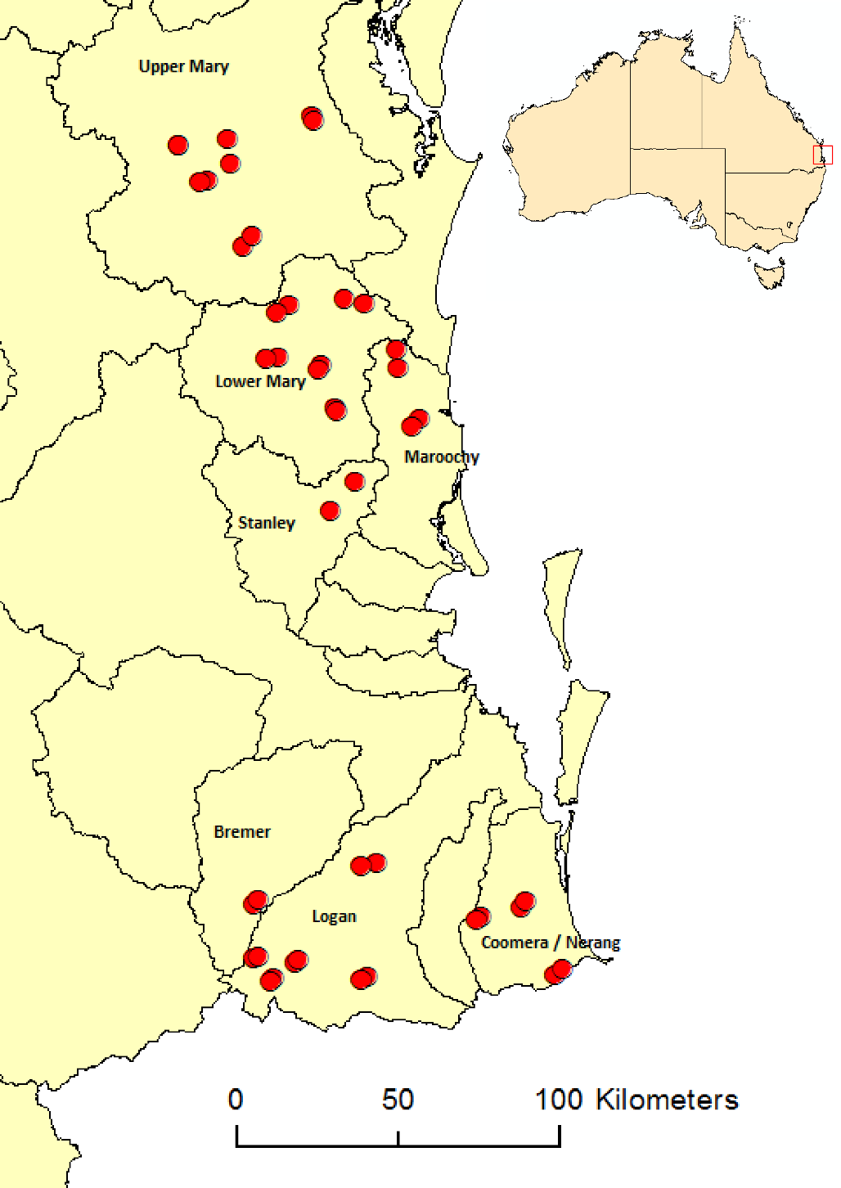

Figure 1. Study area (inset), study catchments and locations of field sites in south-eastern Queensland.

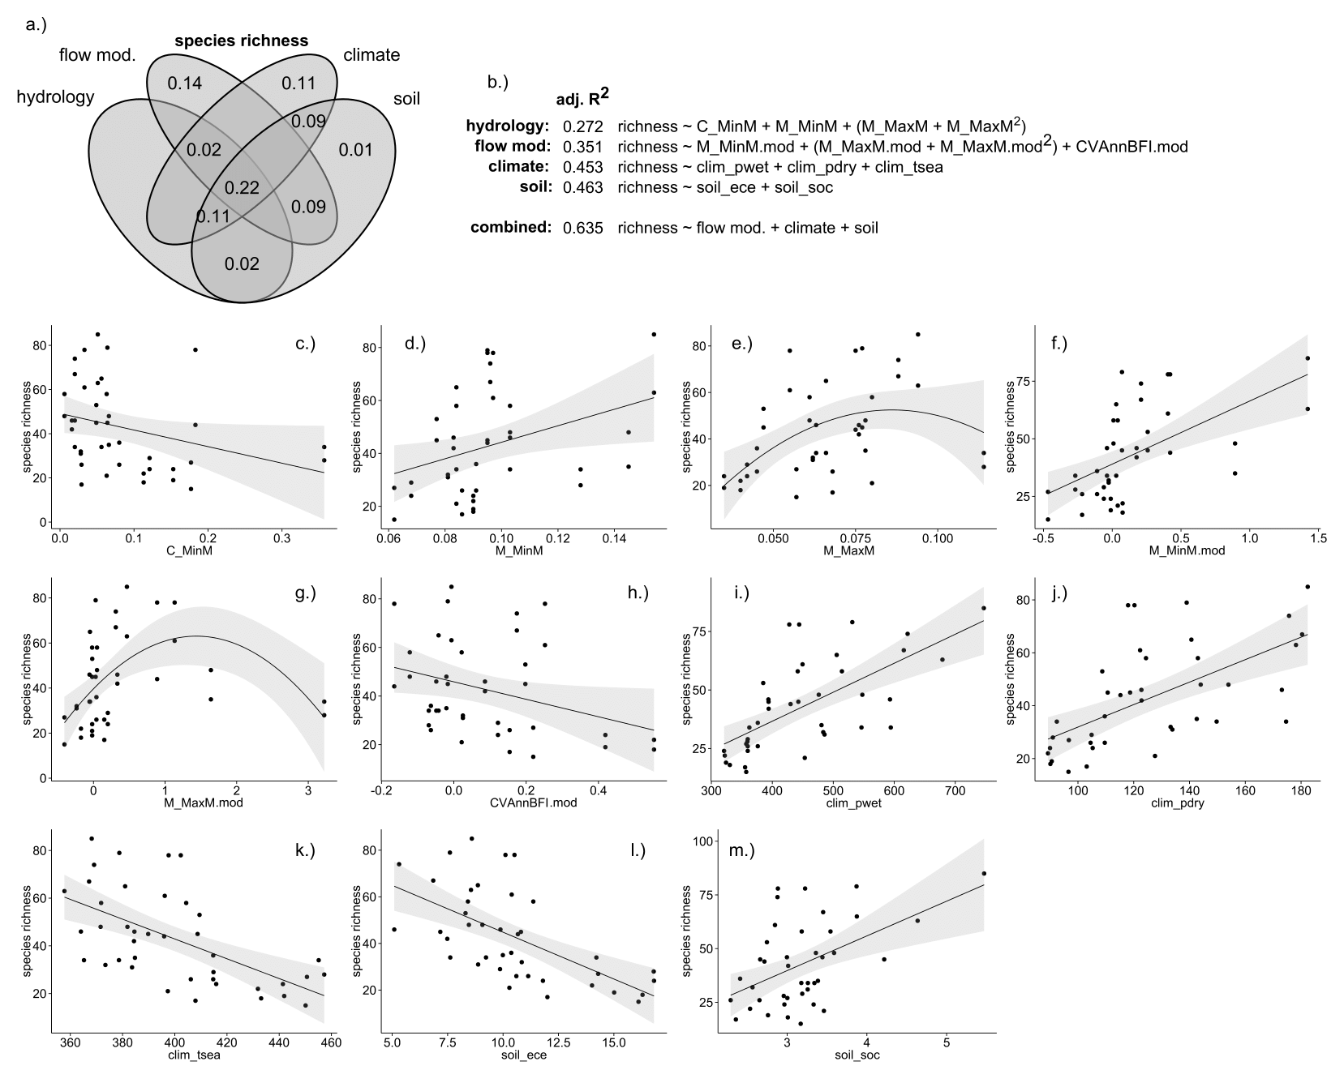

Figure 2. Environmental drivers of area-standardised species richness (units = species per m2) in riparian plant communities. a.) variance partitioning Venn diagram. Numbers within the diagram represent adjusted R2 (adj. R2) values associated with each fraction of variation; b.) multiple regression models representing each set of environmental conditions, and their optimal combination. Quadratic terms are enclosed in parentheses. Selected univariate relationships between species richness and environmental variables describing c.) constancy of monthly minimum daily flows (C_MinM); d.) contingency of monthly minimum daily flows (M_MinM); e.) contingency of monthly maximum daily flows (M_MaxM); f.) modification of contingency of monthly minimum daily flows (M_MinM.mod, % change); g.) modification of contingency of monthly maximum daily flows (M_MaxM.mod, % change); h.) modification of interannual variability in baseflow (CVAnnBFI);i.) precipitation in the wettest quarter of the year (clim_pwet, mm); j.) precipitation in the driest quarter of the year (clim_pdry, mm); k.) temperature seasonality (clim_tsea) l.) soil effective cation exchange capacity (soil_ece, meq per 100 g); m.) soil organic carbon content (soil_soc, %). Species richness is presented as the abundanced-based Chao's Species Estimator. Fitted lines depict ordinary least-squares regression models. Shaded areas depict the smoothed 95 % confidence interval around the regression model.

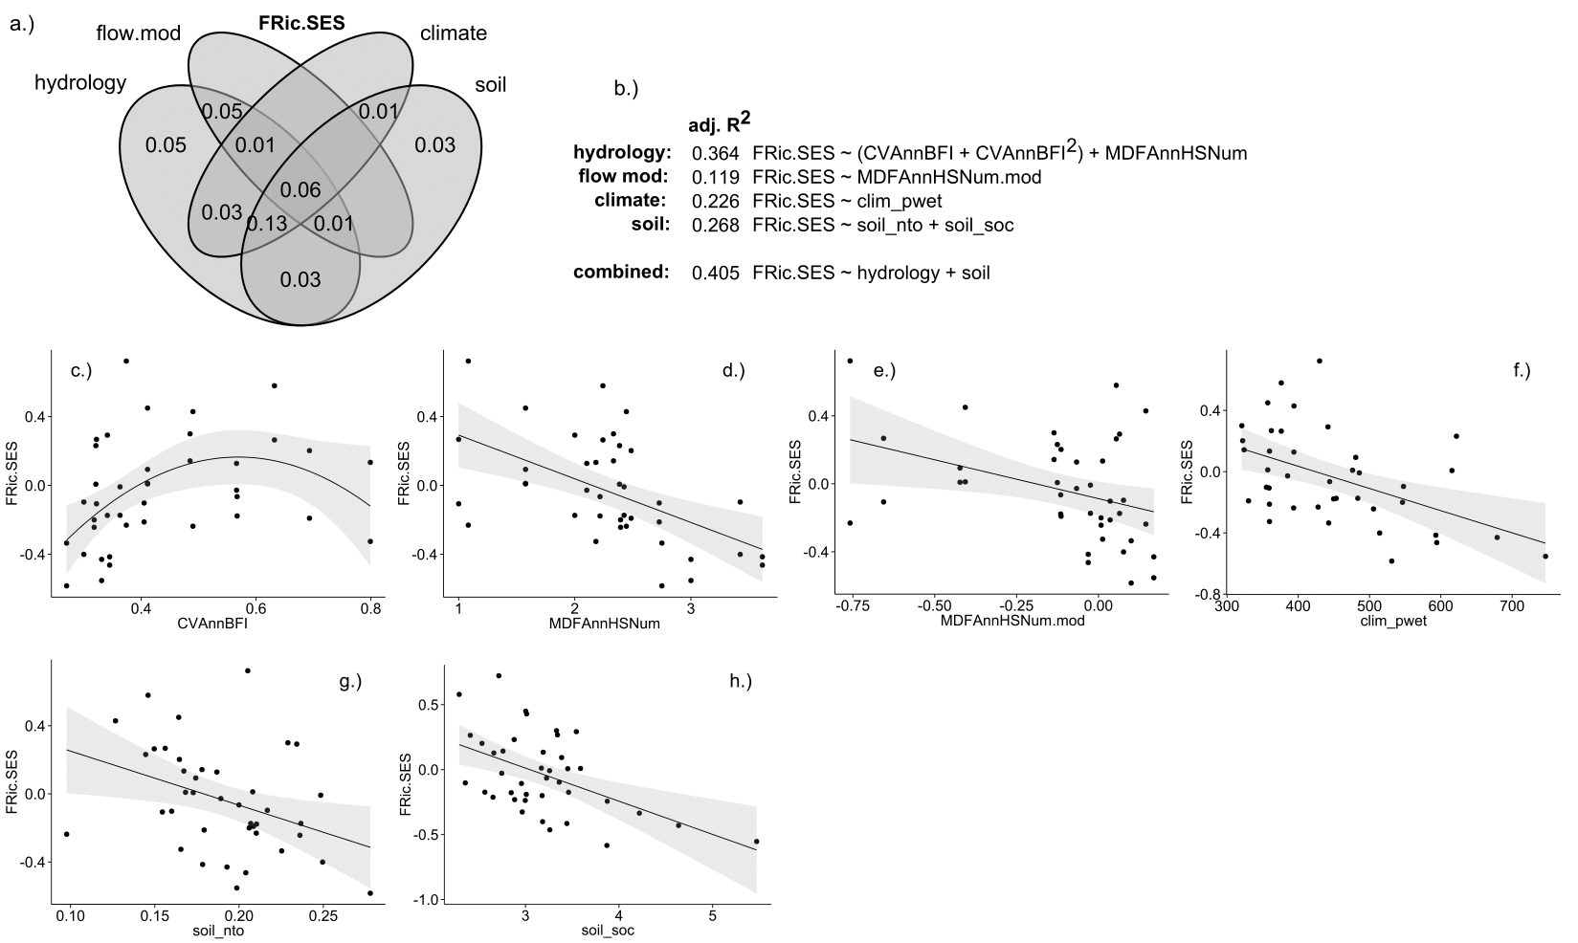

Figure 3. Environmental drivers of standardised effect size functional richness (FRic.SES) in riparian plant communities. a.) variance partitioning Venn diagram. Numbers within the diagram represent adjusted R2 (adj. R2) values associated with each fraction of variation; b.) multiple regression models representing each set of environmental conditions, and their optimal combination. Quadratic terms are enclosed in parentheses. Selected relationships between FRic.SES and environmental variables describing c.) interannual variability in baseflow (CVAnnBFI); d.) mean annual frequency of high flow periods (MDFAnnHSNum); e.) modification of mean annual frequency of high flow periods (MDFAnnHSNum.mod, % change); f.) precipitation in the wettest quarter (clim_pwet, mm); g.) soil total nitrogen (soil_nto, %); h.) soil organic carbon (soil_soc, %). Fitted lines depict ordinary least-squares regression models. Shaded areas depict the smoothed 95 % confidence interval around the regression model.

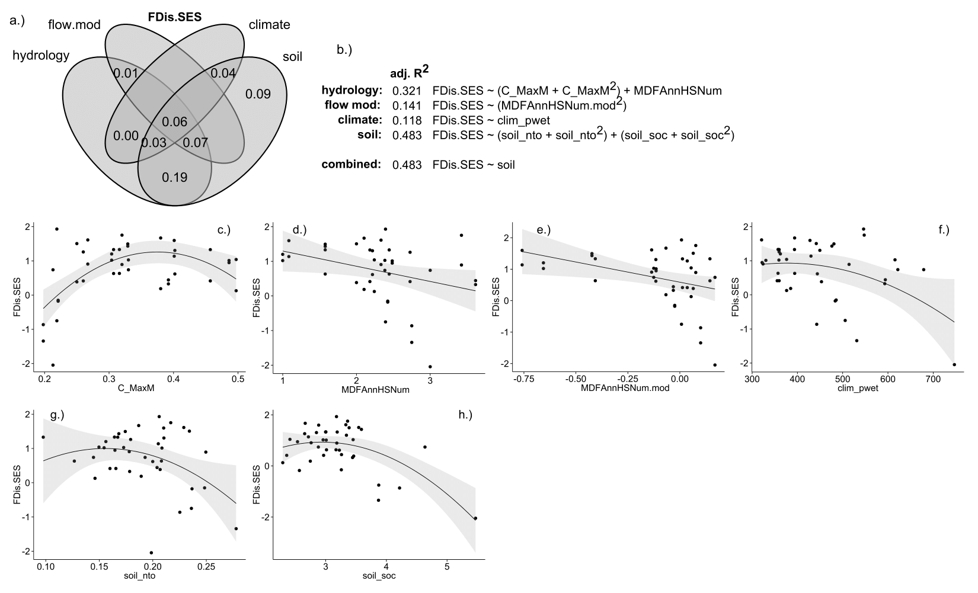

Figure 4. Environmental drivers of standardised effect size functional dispersion (FDis.SES) in riparian plant communities. a.) variance partitioning Venn diagram. Numbers within the diagram represent adjusted R2 (adj. R2) values associated with each fraction of variation; b.) multiple regression models representing each set of environmental conditions, and their optimal combination. Quadratic terms are enclosed in parentheses. Selected relationships between FDis.SES and environmental variables describing c.) constancy of monthly maximum daily flows (C_MaxM); d.) mean annual frequency of high flow periods (MDFAnnHSNum); e.) modification of mean annual frequency of high flow periods (MDFAnnHSNum.mod, % change); f.) precipitation in wettest quarter (clim_pwet, mm); g.) soil total nitrogen (soil_nto, %); h.) soil organic carbon (soil_soc, %). Fitted lines depict ordinary least-squares regression models. Shaded areas depict the smoothed 95 % confidence interval around the regression model.